Hello dearest Central Grader. I have been puzzling about how to format my submission and have decided upon the following layout.
First I will submit a screenshot of the completed assignment, as the submission instructions dictate. This will be the most efficient manner in which you may determine that the assignment has been completed.

Following that I will post screenshots of how I first went about finding the answers, which did not align with the intent of the exercise, but was fun so I did it anyway. Partially, at least.

Thirdly I will present screenshots of completing the assignment in the manner in which it was meant to be completed.

Then, apparently, I’m supposed to include a screenshot of my favorite vacation spot. Not sure where that came from, but when asking about formatting prior to class on Saturday I was told to do so. And so I shall!
Please proceed to the next page.
Abandon yourself to revelry at this incredible result!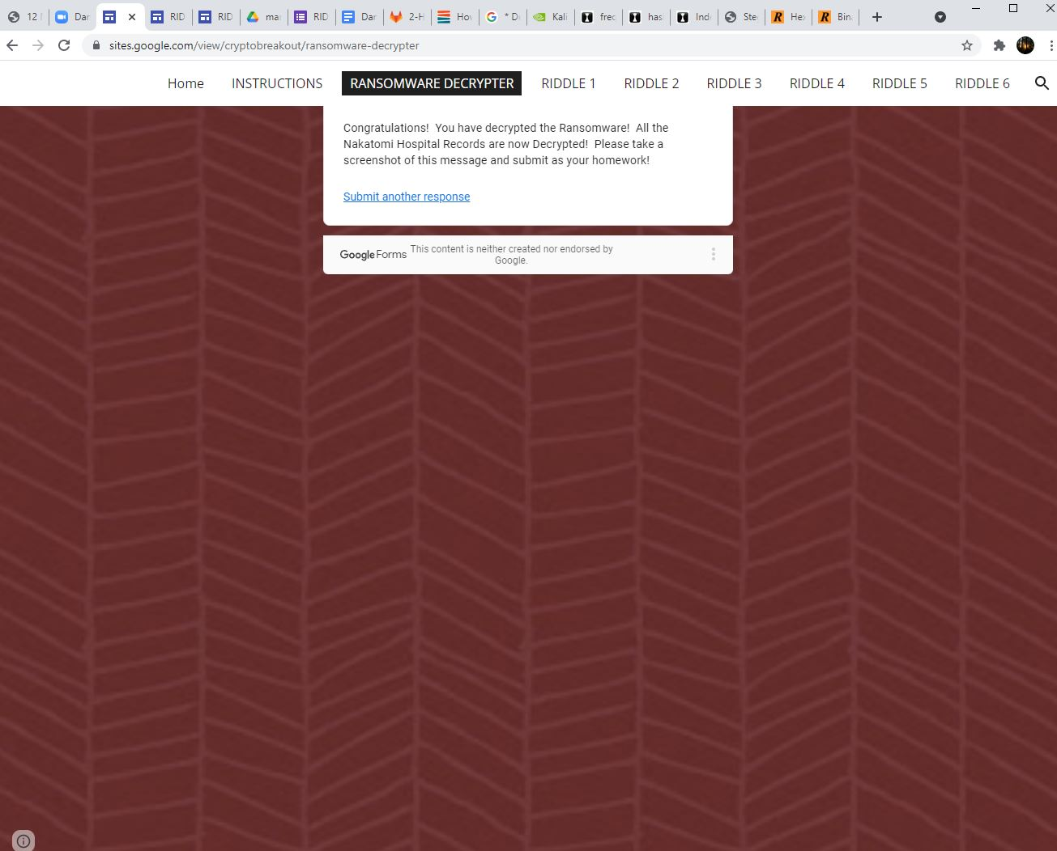

Following this you’ll find me using the browser inspector to find the answers. With my deepest apologies I must admit that it includes several screenshots. Peruse them at your pleasure.

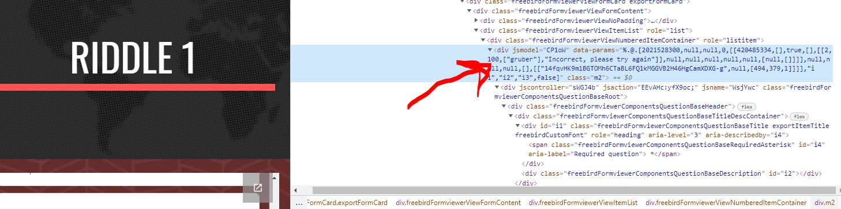
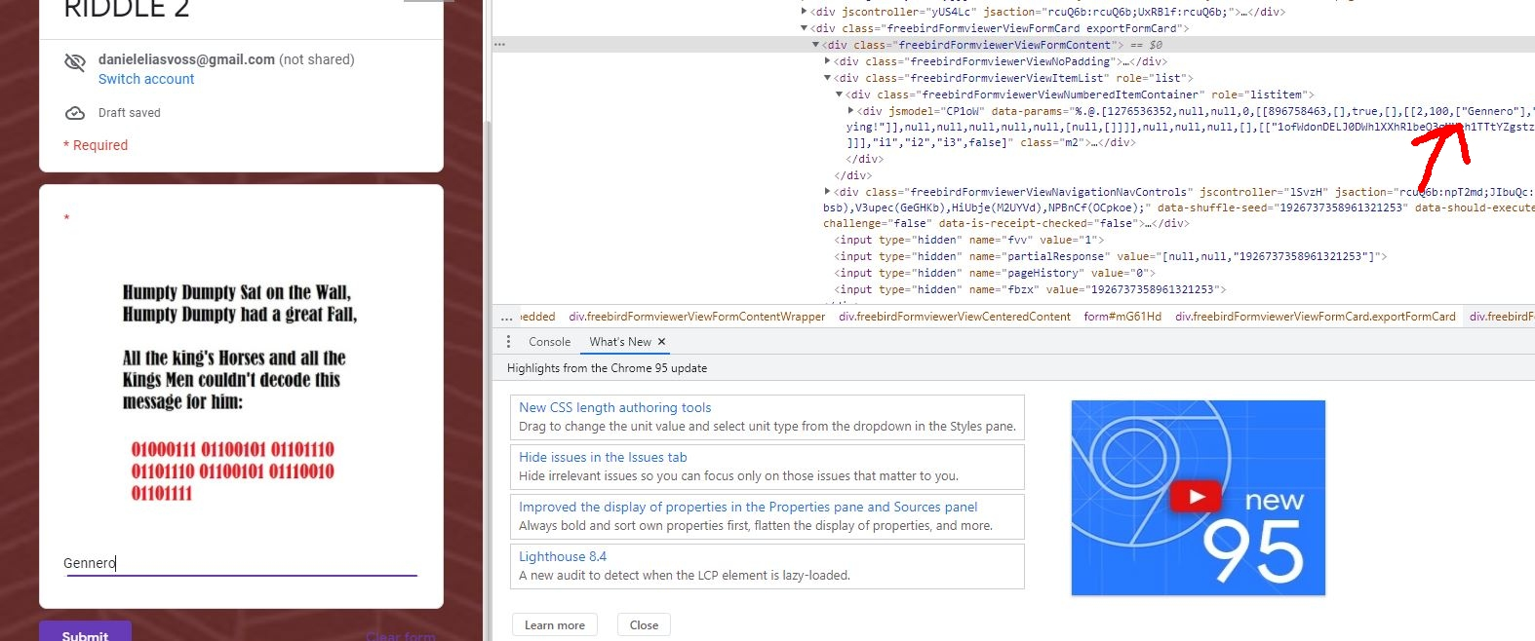

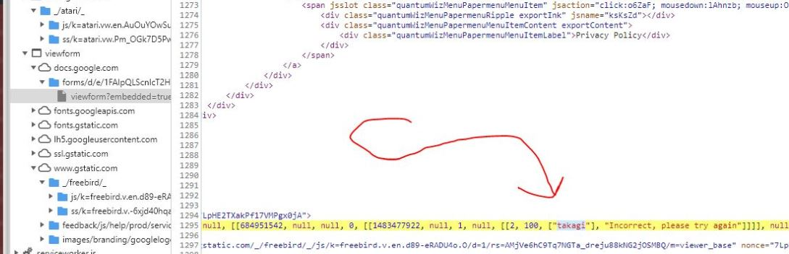

And so on, Dearest Central Grader. however riddle 4 opened a can of worms and at that point I decided to stop being silly and do the actual assignment. Screenshots to follow on subsequent pages. As always, your presumed indulgence of my many screenshots is appreciated deeply.

Now on to what we were supposed to do.
I’m afraid I neglected to screenshot myself subtracting or adding 8 letters (at this point I don’t recall which number it was) but please believe that I solved the Caeser cypher with my eldritch grasp of basic arithmetic.

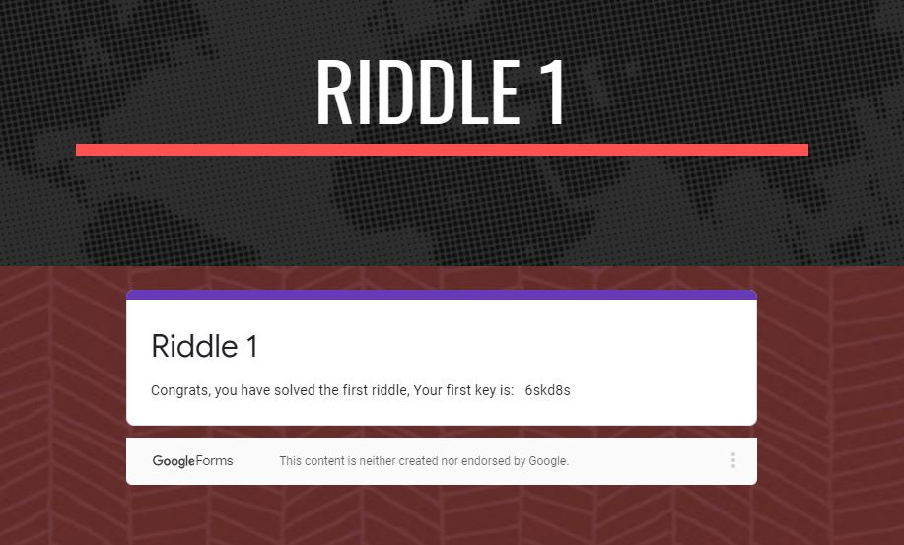

Riddle 2 to follow:

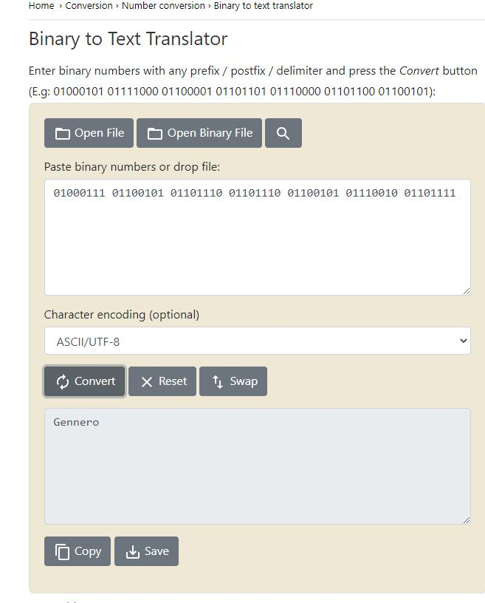
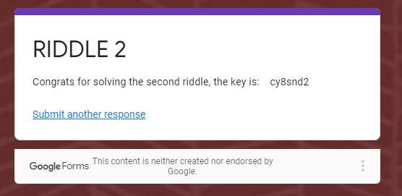
sorry about all the empty space. formatting with images in docs is not my strong suit.
Real answer 3 to follow:
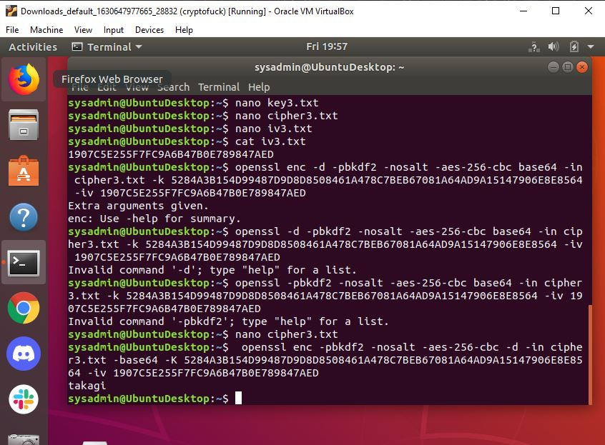

continued |
V

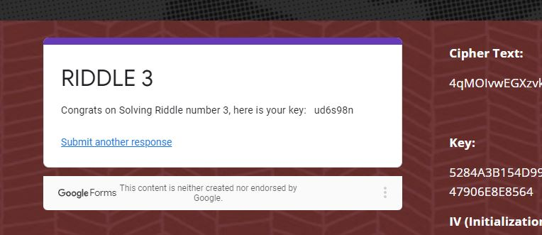

and here comes number 4

eventually...

4.1 = Jill’s public key

4.2 = Jill’s private key

4.3 = 12 Asymmetric and 15 Symmetric

4.4 = Alice’s public key

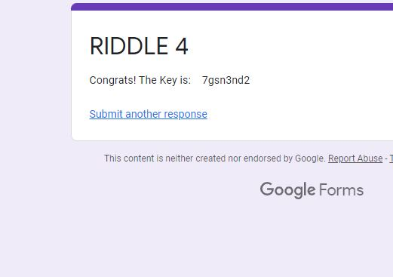

Here comes number 5!

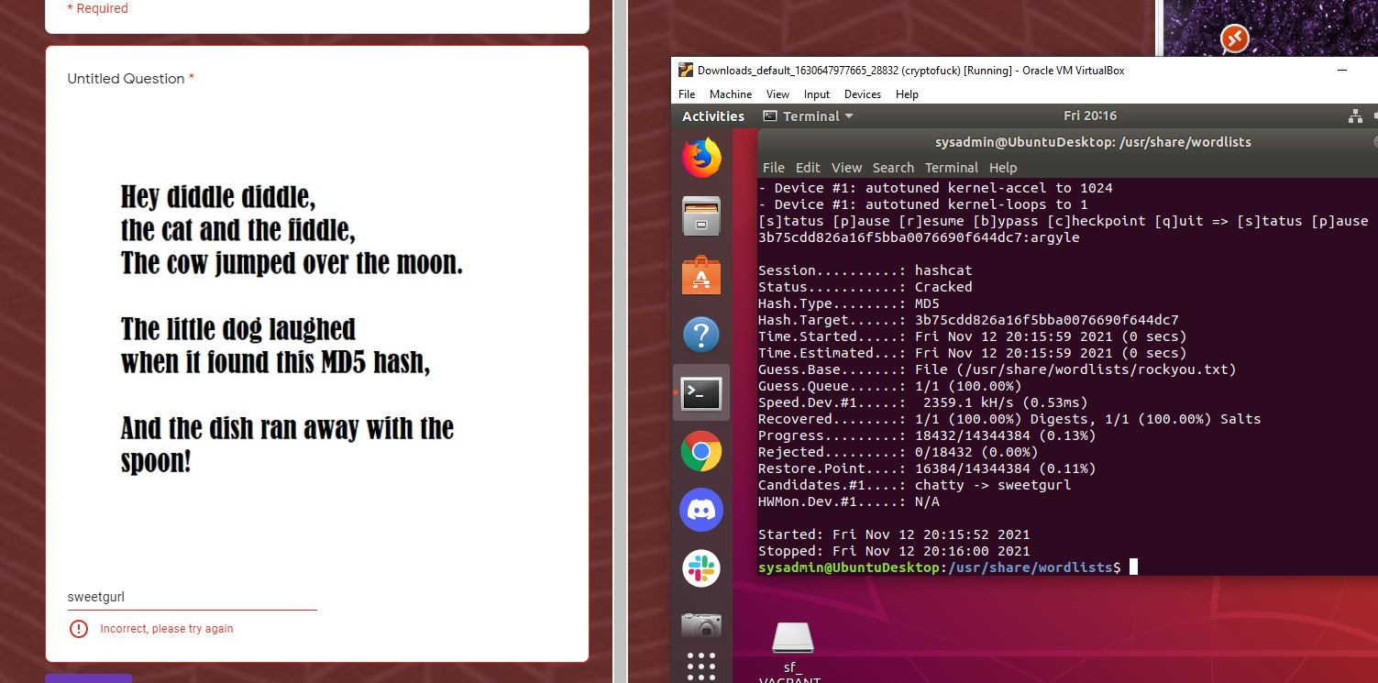

J/K OMG
but seriously

Number 5:

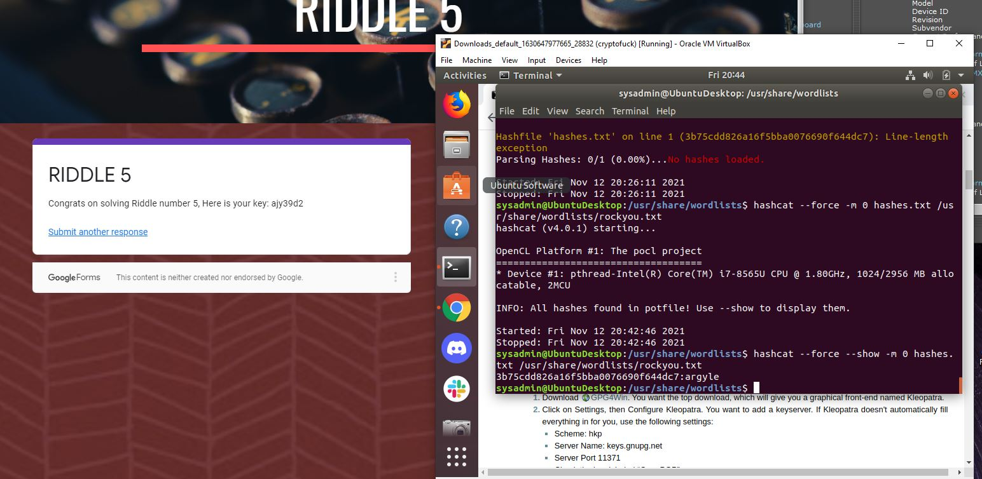

and now for the cherry on the top, number 6!

The sneaky final code was on the cover of Mary’s book.

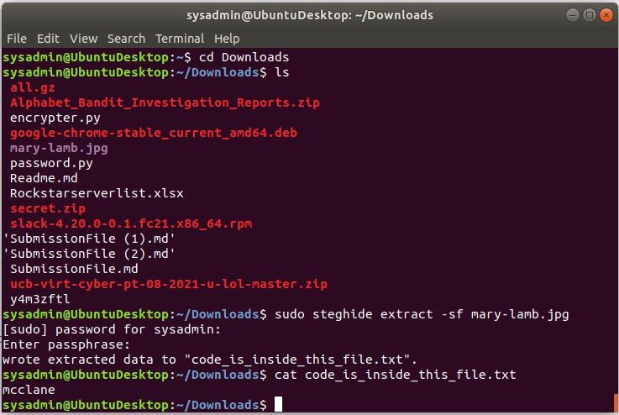

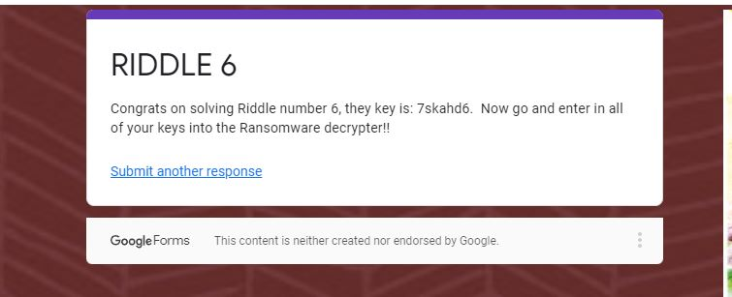
And as per instructions from the teaching staff during office hours prior to class on Saturday the 13th of November I have included a picture of my favorite vacation spot. I think they were just messing with me, but why take the chance. Allow me to introduce you to the Gateway to Hell, located amidst the barren wastes of Turkmenistan <3
